# **Name: Abdurrahman Qureshi**

# **Roll No: 210451**

Practical No: 1 and 2

**1) Program to print hello world in java**

**CODE:**

import java.lang.*;

public class EXP1n2HelloWorld

{

public static void main(String args[])

{

System.out.println("Hello World ");

System.out.println("Abdurrahman Qureshi - 210451");

}

}

**OUTPUT:**

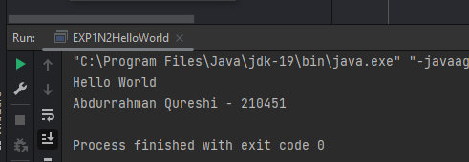

**2) Program to print name and hobby**

**CODE:**

import java.util.*;

class EXP1N2NameandHobby

{

public static void main(String[] args)

{

Scanner scanner = new Scanner(System.in);

System.out.println("Enter your name");

String name = scanner.nextLine();

System.out.println("Enter hobby of " + name) ;

String hobby = scanner.nextLine();

System.out.println(name + " - 210418 \n" + "My hobby is - " + hobby);

}

}

**OUTPUT:**

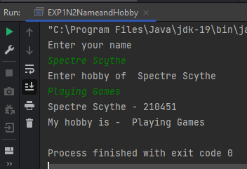

**3) Program to print name and grade and percentage**

**CODE:**

import java.util.Scanner;

class EXP1N2Grade

{

public static void main(String[] args)

{

Scanner userEnteredScannedValue = new Scanner(System.in);

System.out.println("Enter your name");

String name = userEnteredScannedValue.nextLine();

System.out.println("Enter your age");

Integer age = userEnteredScannedValue.nextInt();

System.out.println("Enter your grade");

Character grade = userEnteredScannedValue.next().charAt(0);

System.out.println("Enter your percentage");

int per = userEnteredScannedValue.nextInt();

System.out.println(name + " - 210451 ");

System.out.println("Age is " + age + " \n" + "Grade = " + grade + "\n" + "percentage is " + per);

}

}

**OUTPUT:**

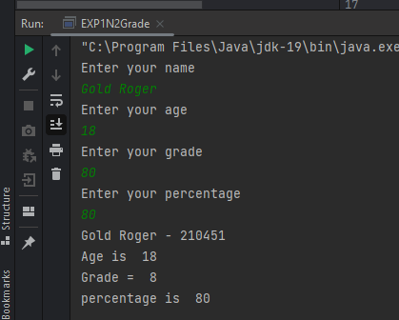

**4) Program to calculate Simple Interest**

**CODE:**

import java.util.*;

class EXP1N2SimpleInterest{

public static void main(String[] args)

{

Scanner sc = new Scanner(System.in);

System.out.println("Enter principle");

int p = sc.nextInt();

System.out.println("Enter the rate of interest");

int r= sc.nextInt();

System.out.println("Enter the no of years");

int n = sc.nextInt();

int si = (p*r*n)/100;

System.out.println("Simple Interest is " + si);

}

}

**OUTPUT:**

